**Assignment -02**

**Exp. Name : UML Activity and Sequence Diagram For ATM**

**Course Code : CSE-326**

**Course Title : System Analysis and Design**

**Submitted To: Sputa Richard Philip**

**Senior Lecture**

**City University**

**Department of computer Science and Engineering**

**Faculty of Science and Engineering**

**Submitted By:**

**ID :171442560**

**Name :Md. Rasel Miah**

**Program :CSE(Eve)**

**Batch : 44th**

**Semester :Spring**

UML ACTIVITY DIAGRAM FOR ATM

Activity diagrams in UML are a leading subset of behavioral diagrams. They display the functionalities of various activities and flows in business processes and software systems. With UML specific symbols,

you can map out the start point, end point, and all the merging and interactions in between your process flow. See our guide on activity diagrams if you need additional information.

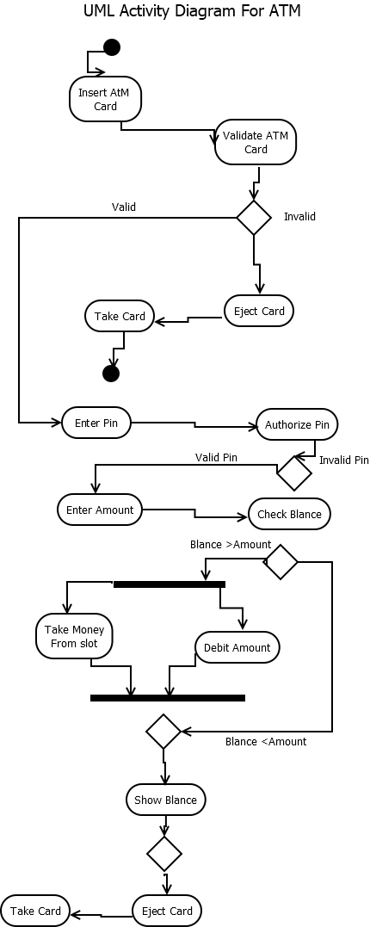

UML SEQUENCE DIAGRAM FOR ATM

Many project managers and engineers use sequence diagrams in UML to get a better idea of how tasks within a project will function, overlap, and move between objects or components. Create sequence diagrams to display interactions between objects and the order in which those interactions occur. You can read our full guide on sequence diagrams

for additional reference. While the examples below cover UML sequence diagrams, Lucidchart still has the shapes and features you need to model code-based sequence diagrams as well.

